NAME: Gnanahasan M
REG NO:192512347
COURSE NAME : ANALOG AND DIGITAL COMMUNICATION (ECA0802)

EX NO: 8a | SIMULATION AND ANALYSIS OF BPSK MODULATION USING CONSTELLATION DIAGRAMS IN MATLAB
DATE:

Objective

i) To generate BPSK symbols from a binary data sequence using phase-shift keying principles.
ii) To Plot and analyze the BPSK signal constellation in the In-Phase (I) and Quadrature (Q) plane.
iii) To investigate the effect of noise on constellation points and evaluate the resulting degradation in symbol detection performance.

Matlab code
clc;
clear;
close all;
%% Objective 1: Generate BPSK symbols
N = 1000; % Number of bits
data = randi([0 1], N, 1); % Random binary sequence
% BPSK Mapping
bpsk_symbols = 2*data - 1;
%% Objective 2: Plot BPSK Signal Constellation
figure;
subplot(1,2,1);
scatter(real(bpsk_symbols), imag(bpsk_symbols), ...
30, 'filled');
hold on;
xline(0,'k','LineWidth',1.5);
yline(0,'k','LineWidth',1.5);
grid on;
axis equal;
xlim([-1.5 1.5]);
ylim([-1 1]);
xlabel('In-Phase (I)');
ylabel('Quadrature (Q)');
title('Ideal BPSK Constellation');
%% Objective 3: Add Noise and Evaluate Performance
SNR = 5; % Signal-to-Noise Ratio (dB)
rx_signal = awgn(bpsk_symbols, SNR, 'measured');

subplot(1,2,2);
scatter(real(rx_signal), imag(rx_signal), ...
15, 'filled');
hold on;
xline(0,'k','LineWidth',1.5);
yline(0,'k','LineWidth',1.5);
grid on;
axis equal;
xlim([-2.5 2.5]);
ylim([-2 2]);
xlabel('In-Phase (I)');
ylabel('Quadrature (Q)');
title(['Noisy BPSK Constellation (SNR = ', num2str(SNR), ' dB)']);
%% Symbol Detection
detected_bits = real(rx_signal) > 0;
% Calculate Errors
num_errors = sum(data ~= detected_bits);
BER = num_errors/N;
fprintf('Number of Transmitted Bits : %d\n', N);
fprintf('Number of Bit Errors : %d\n', num_errors);
fprintf('Bit Error Rate (BER) : %f\n', BER);

Procedure:

Objective 1: Generate BPSK Symbols from a Binary Data Sequence Using Phase-Shift Keying Principles
- Initialize the MATLAB environment and define the number of bits.
- Generate a random binary sequence consisting of 0s and 1s.
- Apply BPSK modulation by mapping binary 0 to −1 and binary 1 to +1.
- Store the generated BPSK symbols for further processing.
- Verify that the symbol sequence contains only two distinct symbol values.
- Prepare the modulated symbols for constellation analysis.

OUTPUT:

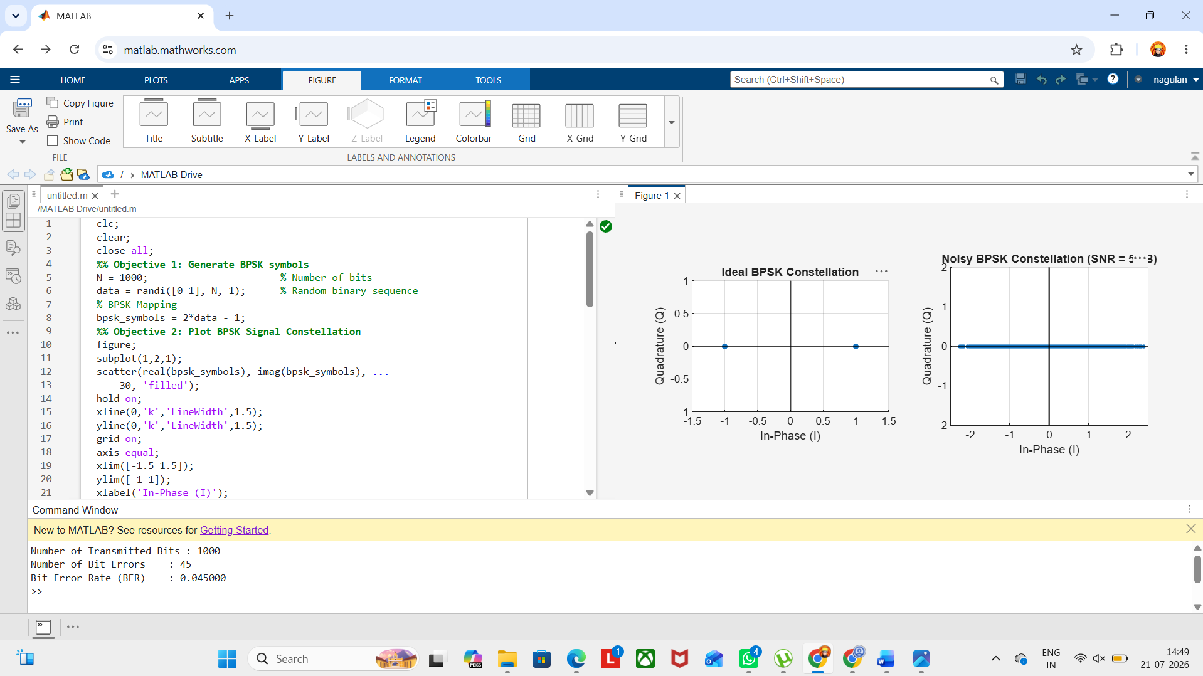

Result :
The BPSK constellation was successfully plotted in the In-Phase (I) and Quadrature (Q) plane, showing two distinct symbol points corresponding to binary 0 and binary 1 for the given SNR.

